Learner Appeals Policy & Procedure
The purpose of an appeals procedure is to ensure that every learner who is not satisfied with the outcome of an assessment decision has the right to appeal against the decision that has been made.
The appeals procedure applies to any learner following completion of an Active IQ qualification at CT Training and provides learners with a formal route to appeal against a decision.
CT Training learners will be assessed against Active IQ published criteria and by assessors who must hold or be working towards any of the following:
- Level 3 Award in Understanding the Principles and Practices of Assessment (QCF) or
- Level 3 Award in Assessing Vocationally Related Achievement (QCF) or
- Level 3 Award in Assessing Competence in the Work Environment (QCF) or
- Level 3 Certificate in Assessing Vocational Achievement (QCF), or
- A1 (previously D32, D33)
In addition, CT Training will ensure that assessors:
- Possess a discipline specific qualification equivalent to the qualification being taught
- Have relevant industry experience
- Demonstrate active involvement in a process of industry relevant Continued Professional
Development during the last two years
All new CT Training assessors will be given a clear action plan for achieving the appropriate qualification(s) and should be countersigned by an appropriately qualified individual until the qualification(s) are achieved.
The appeal procedure to be followed comprises of 4 stages;
Stage 1
The learners first step should be to discuss the matter with their tutor/assessor. At this stage the learner will have the opportunity to express their views and raise any concerns.
In most cases a satisfactory conclusion can be reached at this point, however, if the learner remains dissatisfied with the decision they may, within two weeks, go to stage 2 of the appeal process.
Stage 2
If the learner is not satisfied with the outcome of stage 1, the learner may take a formal written appeal to the Internal Verifier to review the assessment decision.
The Internal Verifier will then discuss their decision/recommendations with both the learner and the Tutor/Assessor.
In most cases a satisfactory conclusion can be reached at this point, however, if the learner remains dissatisfied with the decision they may, within two weeks, go to stage 3 of the appeal process.

Stage 3
If the learner feels the Internal Verifiers decision is wrong, the learner will have the right to take it to CT Training Head of Education, James Vaughan, who will look at the details recorded of the disagreement and then attempt to resolve the matter. The learner can contact James Vaughan at info@cellartapesuk.com
If the learner remains dissatisfied with the decision they may, within two weeks, go to stage 4 of the appeal process.
Stage 4
This is the final stage of the appeals procedure. If you have genuine grievance of which has not been fairly dealt with, then CT Training will log the appeal with Active IQ on behalf of the learner, to fully resolve the matter.
Learner Appeals Policy & Procedure
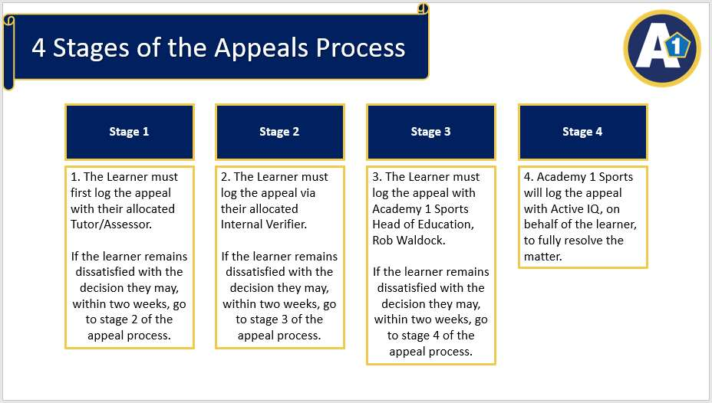
Throughout the assessment process CT Training will comply fully with Active IQ’s policy on reasonable adjustments and special considerations that can be found: https://www.activeiq.co.uk/for-centres/policies-and-procedures
Investigating appeals is very problematic without the presence of impartial evidence. Therefore, appeals in the context of live observed assessments will only be considered when accompanied by a suitable video recording.
As a learner of CT Training you will be able to use a video recording as long as it does not

Learner Appeals Policy & Procedure
adversely affect the assessment process, allows the assessor to carry their role and does not contravene a venue/organisations rules or regulations. The learner must make suitable arrangements to arrange a video operator.
Thank you for your contribution and commitment to making our policy work.

